STUDENT RESULT MANAGEMENT

1. Introduction

This document aims at defining overall software requirement for ACADEMIC RESULT

MANAGEMENT SYSTEM .Efforts have been made to define the requirements

exhaustively and accurately. The final product will be having only

features/functionalities mentioned in this document and assumptions for any

additional functionality/feature should not be made by any of the parties involved

in developing/testing/implementing /using this product .

1.1 Purpose

This specification document describes the capabilities that will be provided by the

software application STUDENT RESULT MANAGEMENT SYSTEM .It also states the

various constraints by which the system will abide. The intended audience for this

document are the development team, testing team and end users of the produc

Table of Contents

1. INTRODUCTION.....................................................................................................................................................1

1.1 PURPOSE...............................................................................................................................................................1

1.2 SCOPE....................................................................................................................................................................1

1.3 DEFINITIONS, ACRONYMS, AND ABBREVIATIONS................................................................................................1

1.4 REFERENCES.........................................................................................................................................................1

1.5 OVERVIEW

2. GENERAL DESCRIPTION....................................................................................................................................2

2.1 PRODUCT PERSPECTIVE........................................................................................................................................2

2.2 PRODUCT FUNCTIONS...........................................................................................................................................2

2.3 USER CHARACTERISTICS......................................................................................................................................2

2.4 GENERAL CONSTRAINTS.......................................................................................................................................2

2.5 ASSUMPTIONS AND DEPENDENCIES......................................................................................................................3

3. SPECIFIC REQUIREMENTS................................................................................................................................2

3.1 EXTERNAL INTERFACE REQUIREMENTS...............................................................................................................3

3.1.1 User Interfaces.............................................................................................................................................3

3.1.2 Hardware Interfaces....................................................................................................................................4

3.1.3 Software Interfaces......................................................................................................................................4

3.1.4 Communications Interfaces..........................................................................................................................4

3.2 FUNCTIONAL REQUIREMENTS...............................................................................................................................4

3.3 OTHER REQUIREMENTS........................................................................................................................................4

4. ANALYSIS MODELS..............................................................................................................................................5

4.1 FLOW CHART........................................................................................................................................................5

4.2. MODULE DESCRIPTION........................................................................................................................................5

PRESENTED BY:

SHANMUGA PRIYA

MAHALAKSHMI

SAI VARSHINI

1. Project overall description:

Student mark analyzing system has been designed to carry out the mark analysis process in an educational institution. The results of respective departments can be efficiently computed without much of manual involvement.

* 1. SCOPE:

The application will manage the information about various students enrolled in this course in different years, the subjects offered during different semesters of the course, the marks obtained by the various students in various subjects in different semesters. The application will greatly simplify and speed up the result preparation and management process.

1. PROJECT USAGE:-

i.Invalid marks:

In Basic flow, if invalid marks are entered, the system displays an error message and prompts for a valid mark. The faculty must enter a valid mark or cancel the operation in which case, the use case ends.

ii. Marks already entered:

If in basic flow, the student mark has already been entered,

the system displays the read only copy of marks and informs the

faculty that the mark has already been entered. So, no changes can

be made to it. The faculty acknowledges the message and the use

case ends.

iii. Fields left empty:

If in basic flow, the field is left empty, the system prompts

the faculty to correct the error. The faculty can enter the mark or

mark the student as absent

Pre Condition:

The faculty must be logged on to the system before the use case

begins.

Post Condition:

If the use case was successful, the student mark is saved to system.

2.1 PROJECT CONSTRAINT:-

i. Marks unavailable:

If in basic flow, the information about student marks could not be

located, the system displays error message and use case ends.

ii. Results already calculated:

If in basic flow, the result has already been calculated, the system

displays the copy of the information and informs mark analyzer that marks have already been processed. The mark analyzer acknowledges the

message and the use case ends.

Pre Condition:

The mark analyzer must be logged on to the system before this use

case begins.

Post Condition:

If the use case was successful, the processed mark information is

saved to the system otherwise the system status is unchanged.

UML DIAGRAMS:

Class diagram:-

A class diagram represents the structure of the system. It shows set of classes, interfaces, and relationships between them.

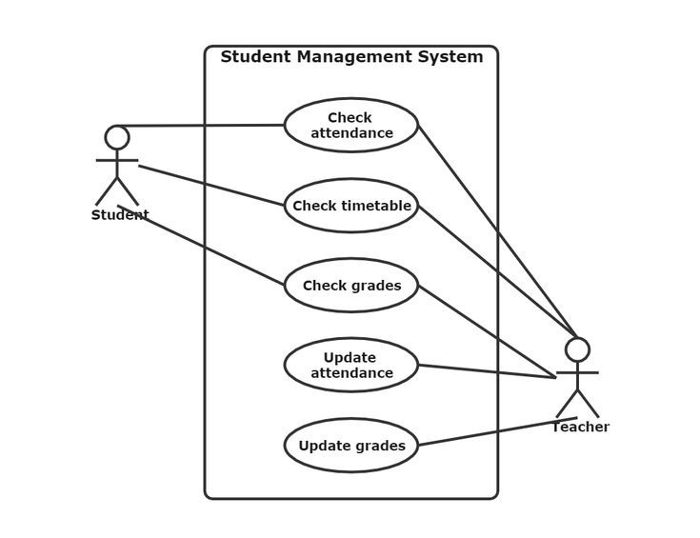

1. SPECIFIC REQUIREMENTS:-

3.1 Functional Requirements:-

Depending upon the user role he/she will be able to access only the specific modules of the system.

1) Login facility for enabling only authorized access to the system

2) User (with role Data Entry operator) will be able to modify /add/delete information about different students that are enrolled for the course in different years .

* 1. NON- FUNCTIONAL REQUIREMENT:-

1. . Safety Requirements:

The database may get crashed at any certain time due to virus or operating system failure. Therefore, it is required to take the database backup

2 . Security Requirements:

We are going to develop a secured database for the university .Depending upon the category of user the access rights are decided. It means if the user is an administrator then he can be able to modify the data, delete, append etc. All other users other than staff only have the rights to retrieve the information about database.

3. Hardware Constraints:

The system requires a database in order to store persistent data. The database should have backup capabilities.

1. SOFTWARE AND HARDWARE SPECIFICATIONS

4.1 Software requirements:-

Operating System: Window 2000, XP

User interface : Java, Servlets, JSP

Database : My SQL

Documentation Tool : Ms Office

4.2 Hardware requirements:-

Processor: Standard processor with a speed of 1.6 GHz or more

RAM: 256 MB RAM or more

Hard Disk: 20 GB or more

Monitor: Standard color monitor

Keyboard: Standard keyboard

Mouse: Standard mouse